**Week 3**

**Spring Data JPA - Quick Example**

**Screenshots to the steps performed**

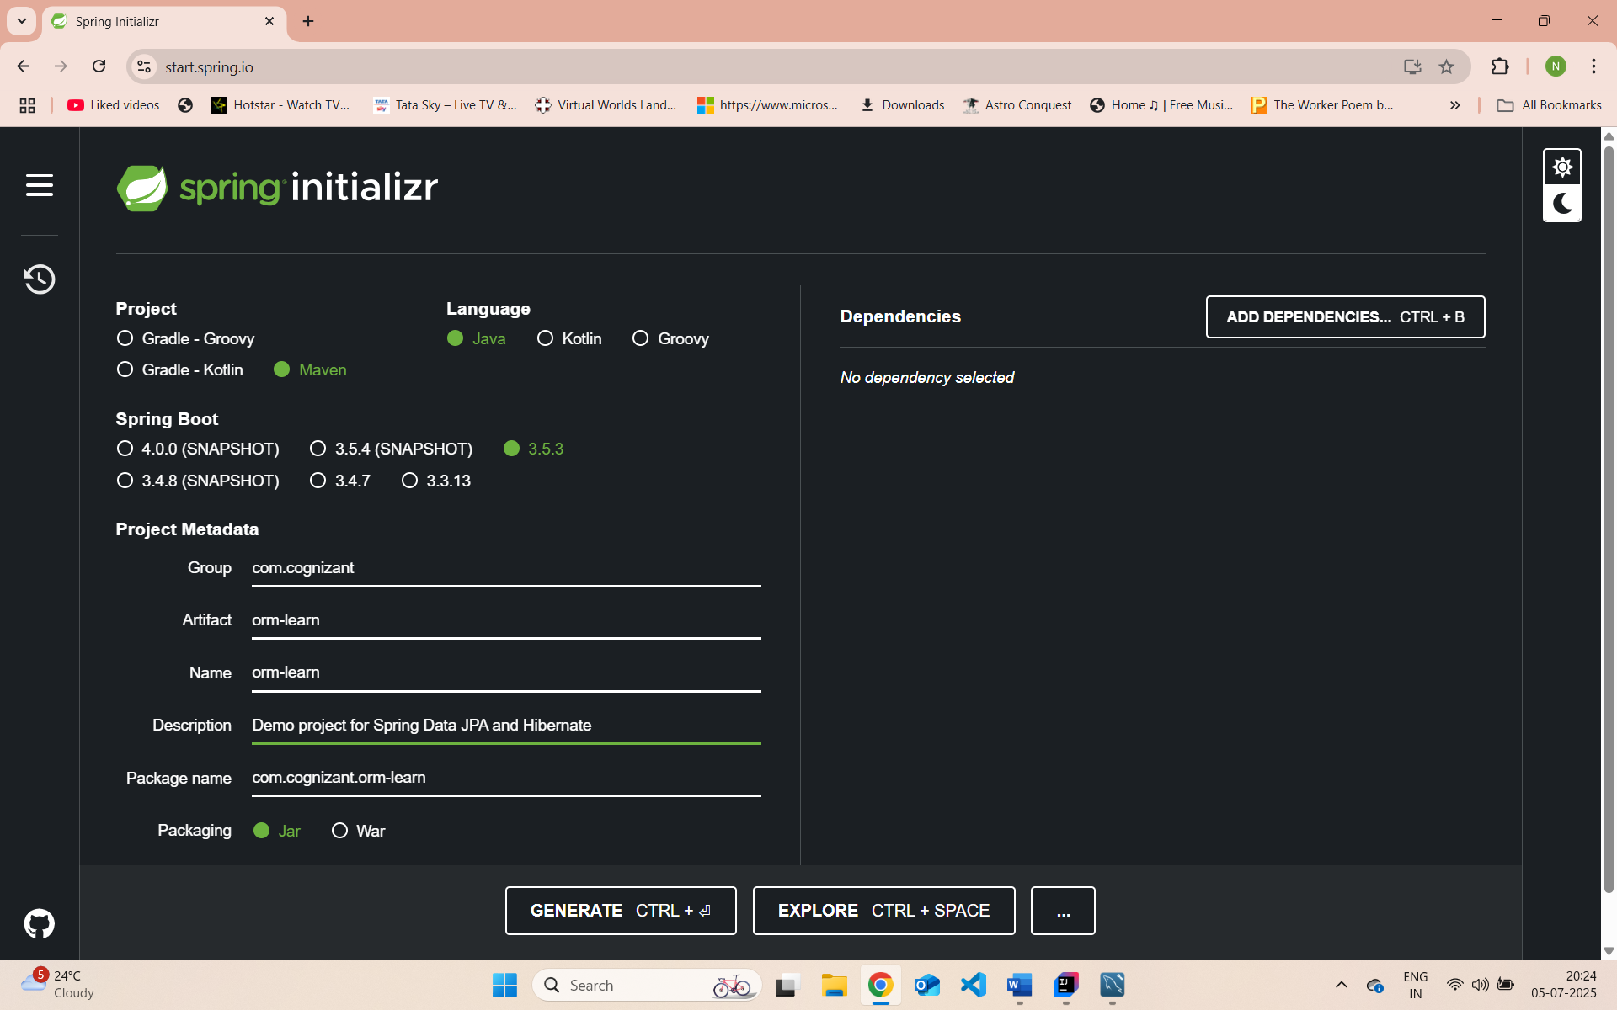

Mysql ormlearn :

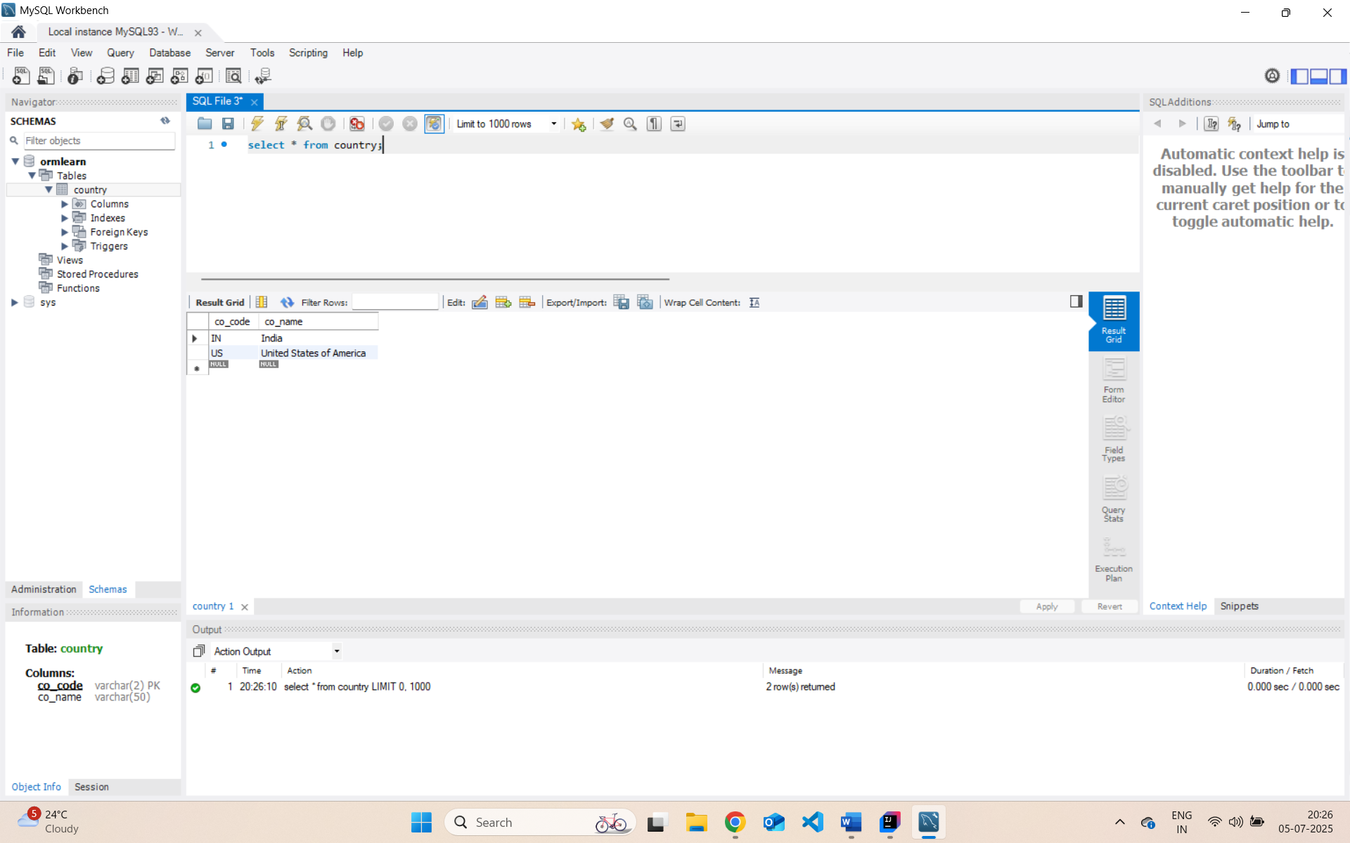

Project orm-learn:

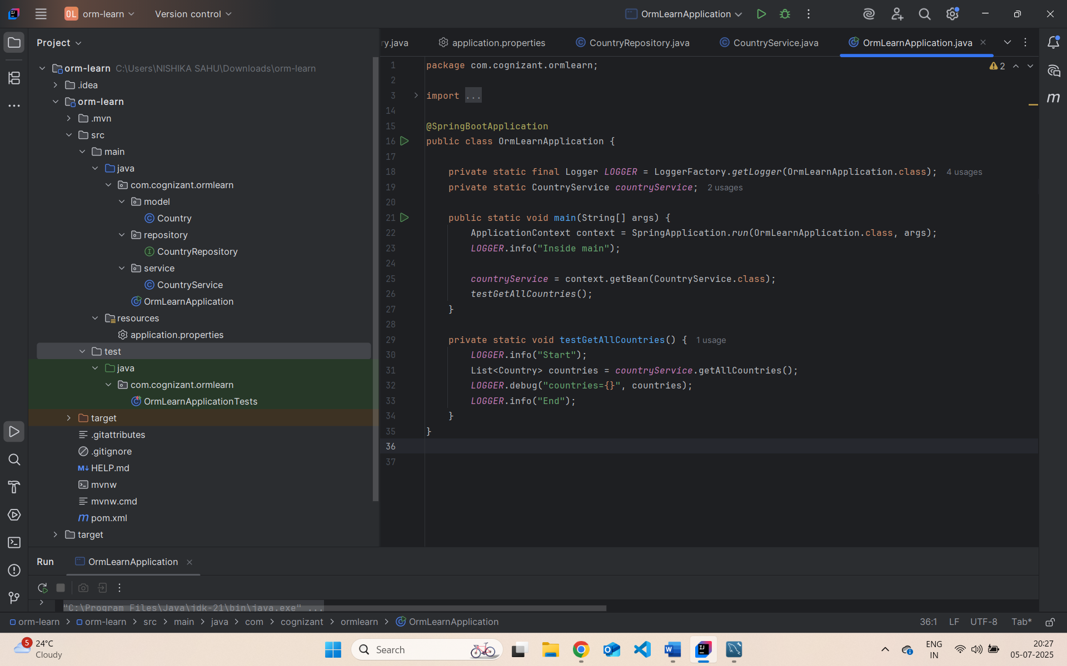

com.cognizant.ormlearn.model.Country :

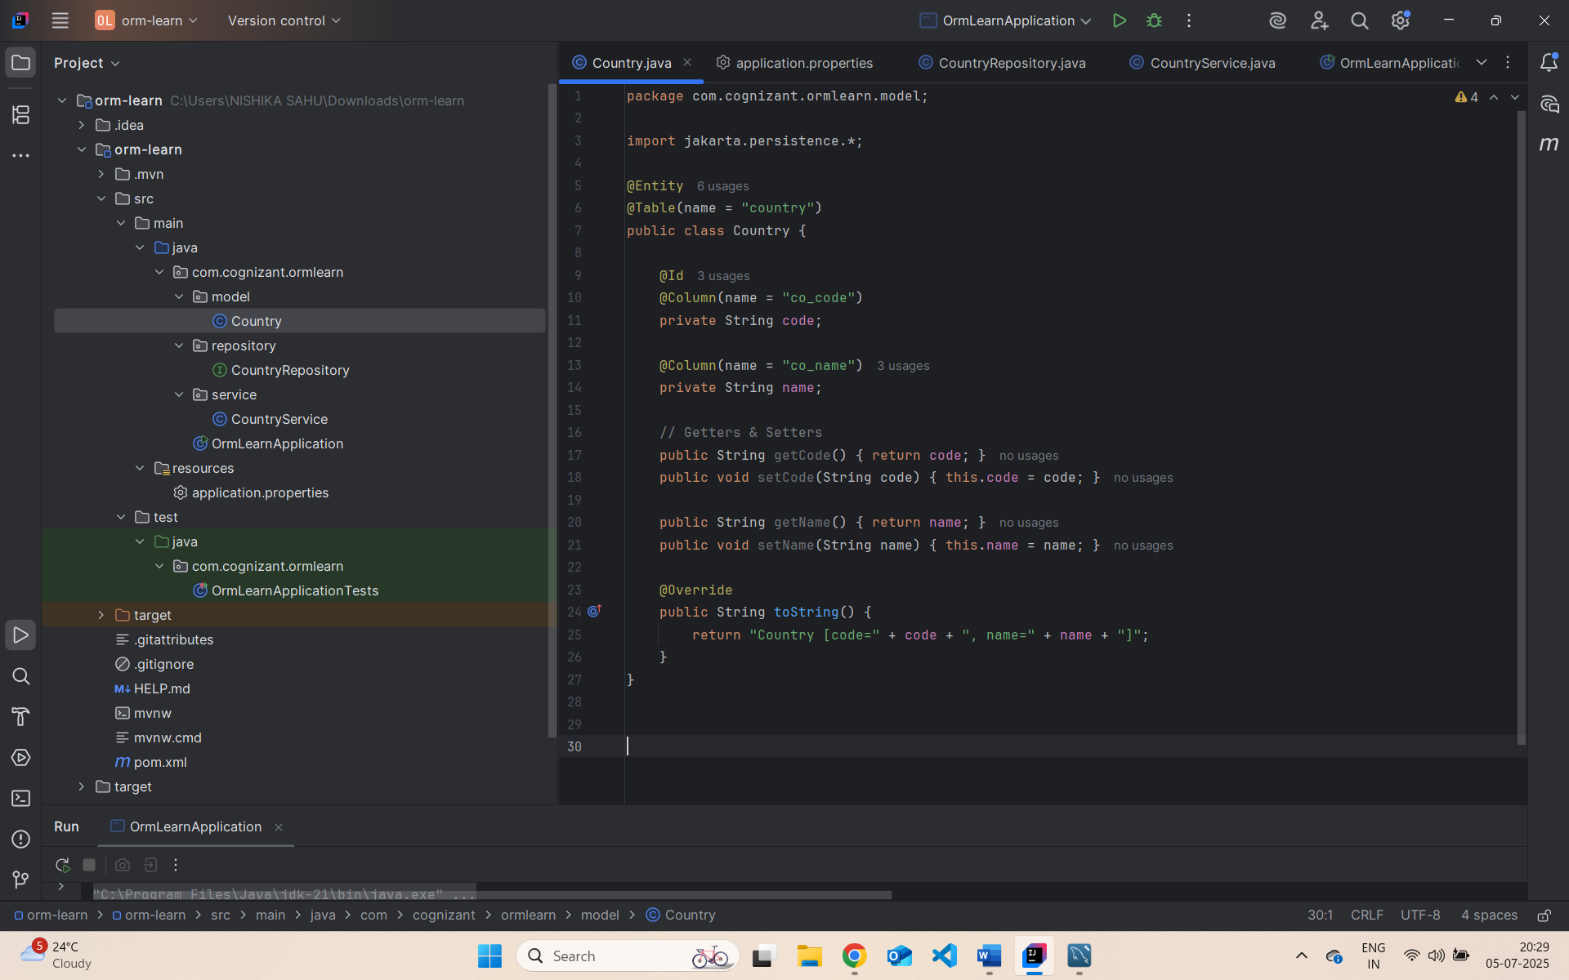

com.cognizant.ormlearn.repository.CountryRepository :

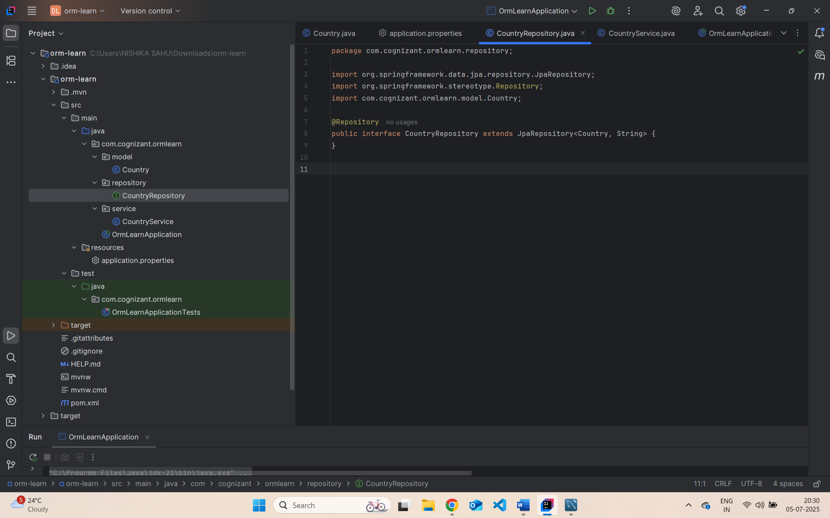

com.cognizant.ormlearn.service.CountryService :

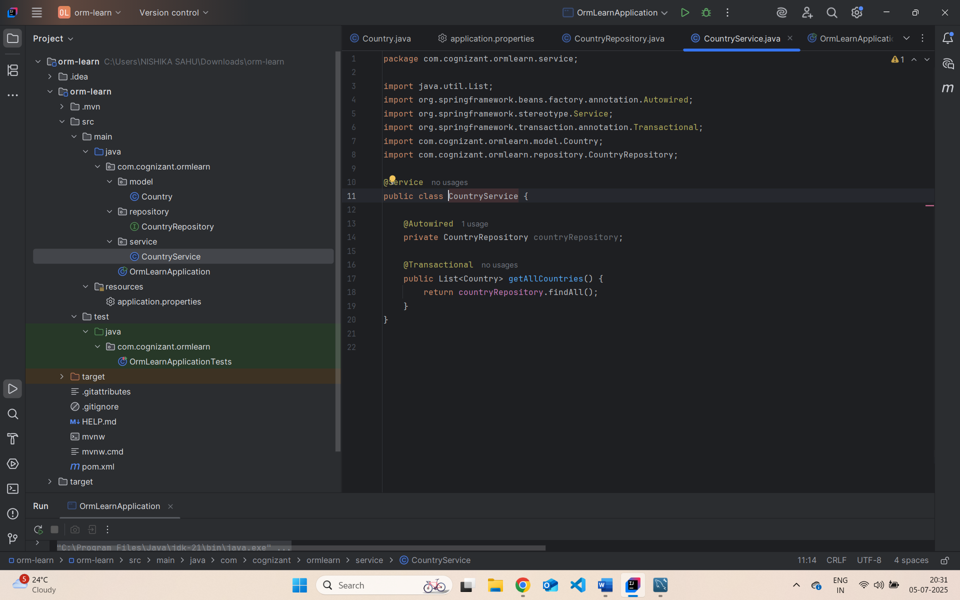

Com.cognizant.ormlearn.OrmLearnApplication.java :

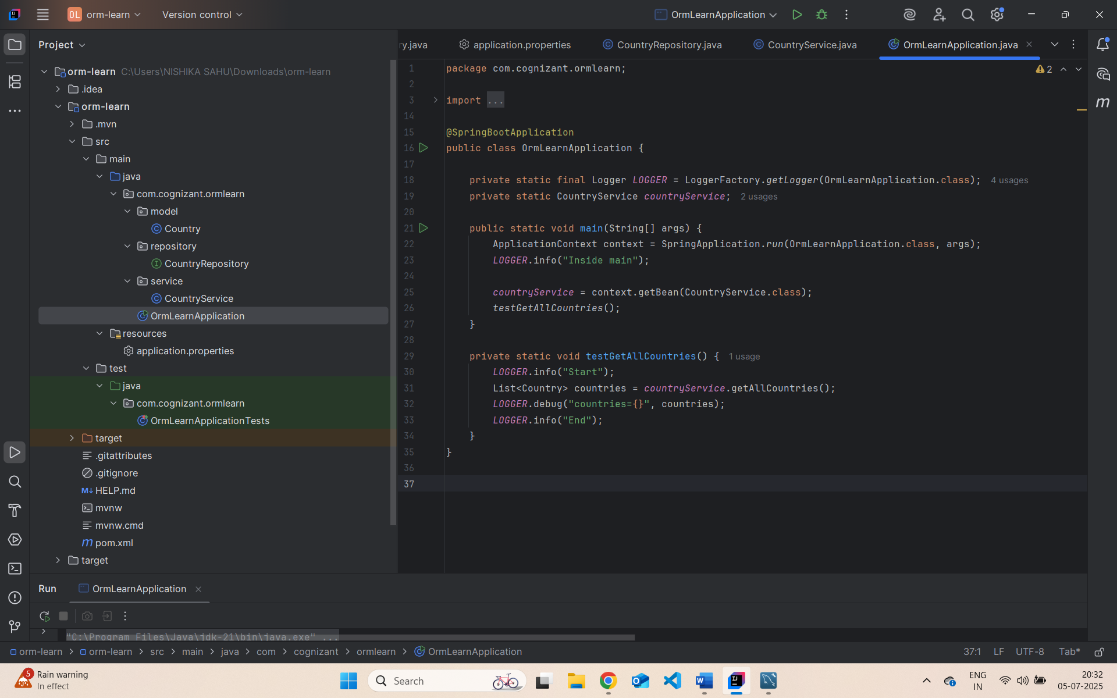

Application.properties :

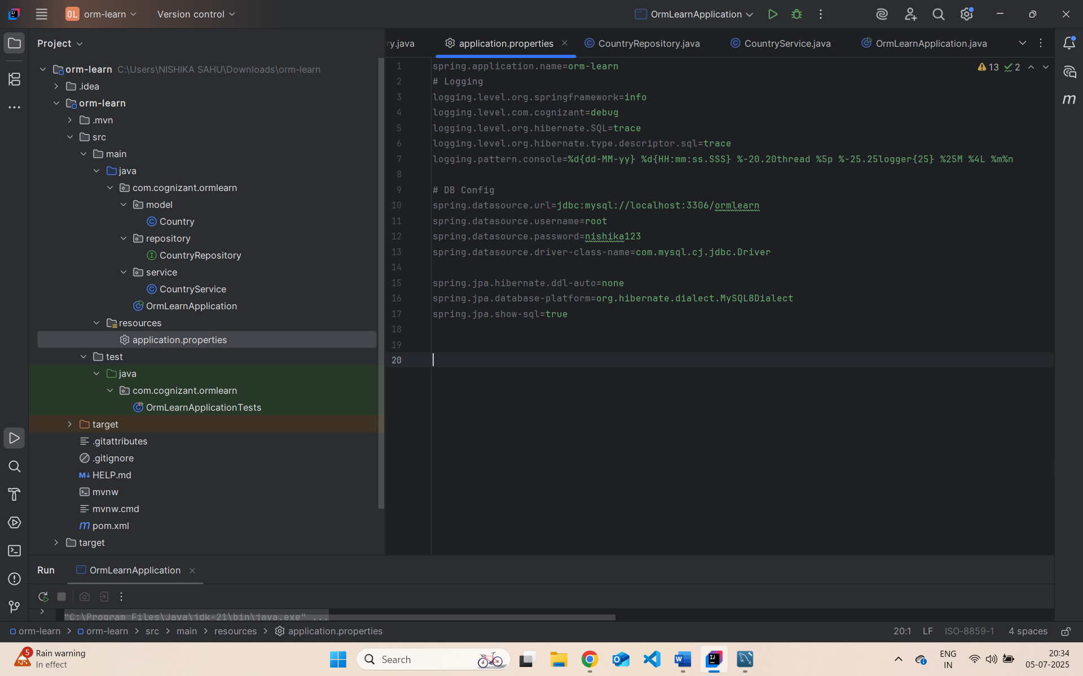

com.cognizant.ormlearn.OrmLearnApplicationTests.java :

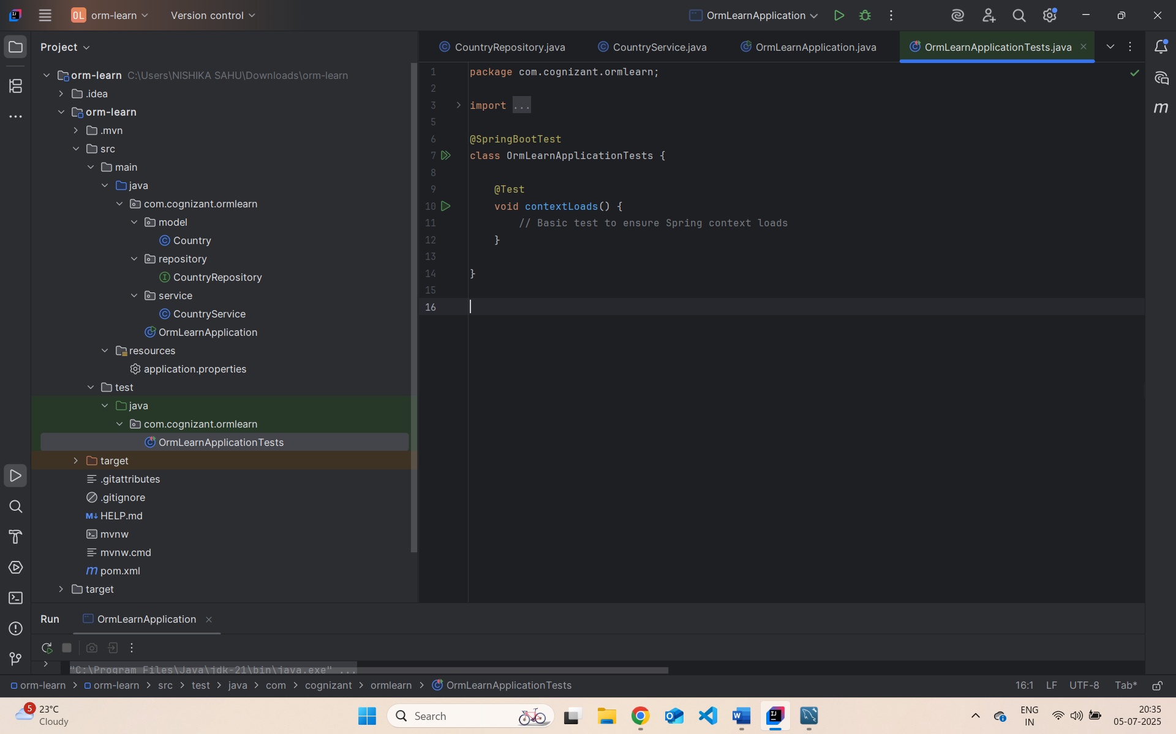

Output :

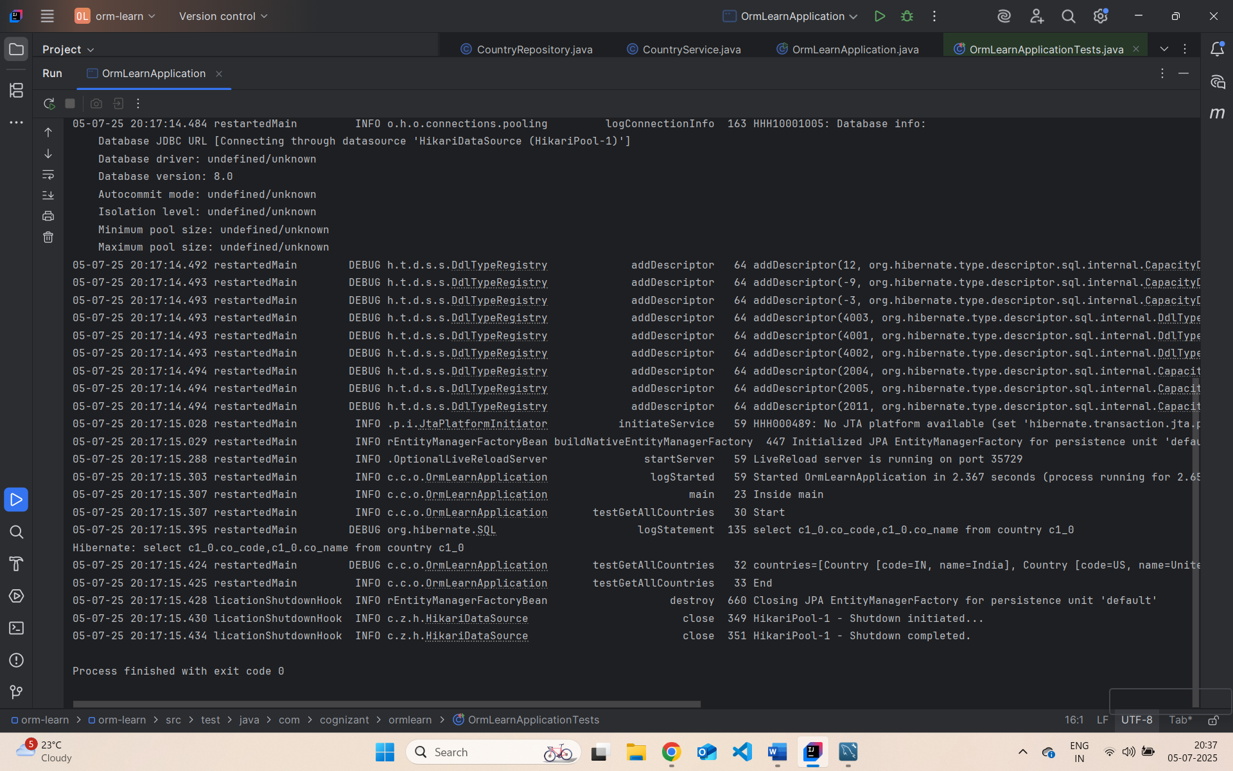

**Difference between JPA, Hibernate and Spring Data JPA**

Hibernate:

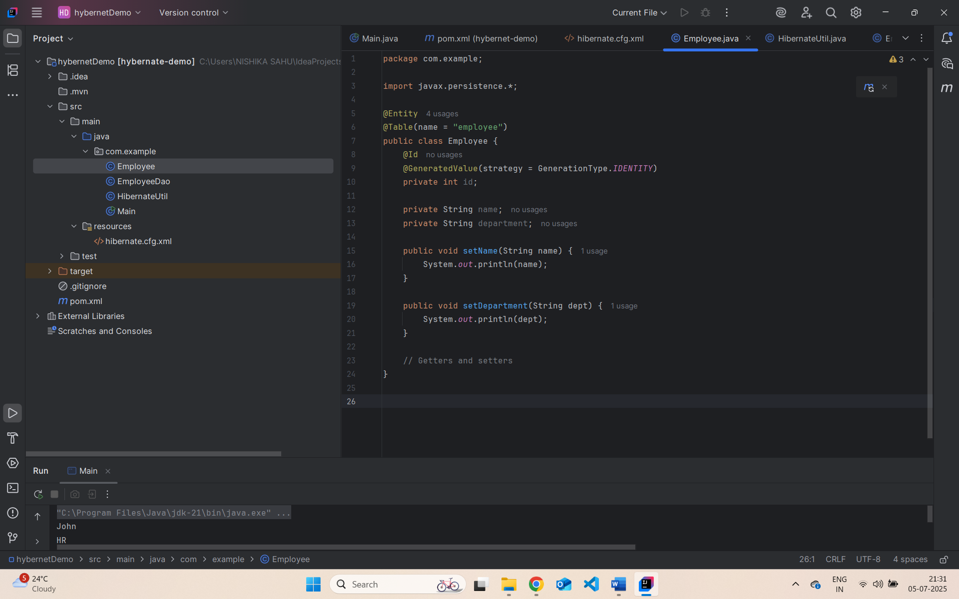 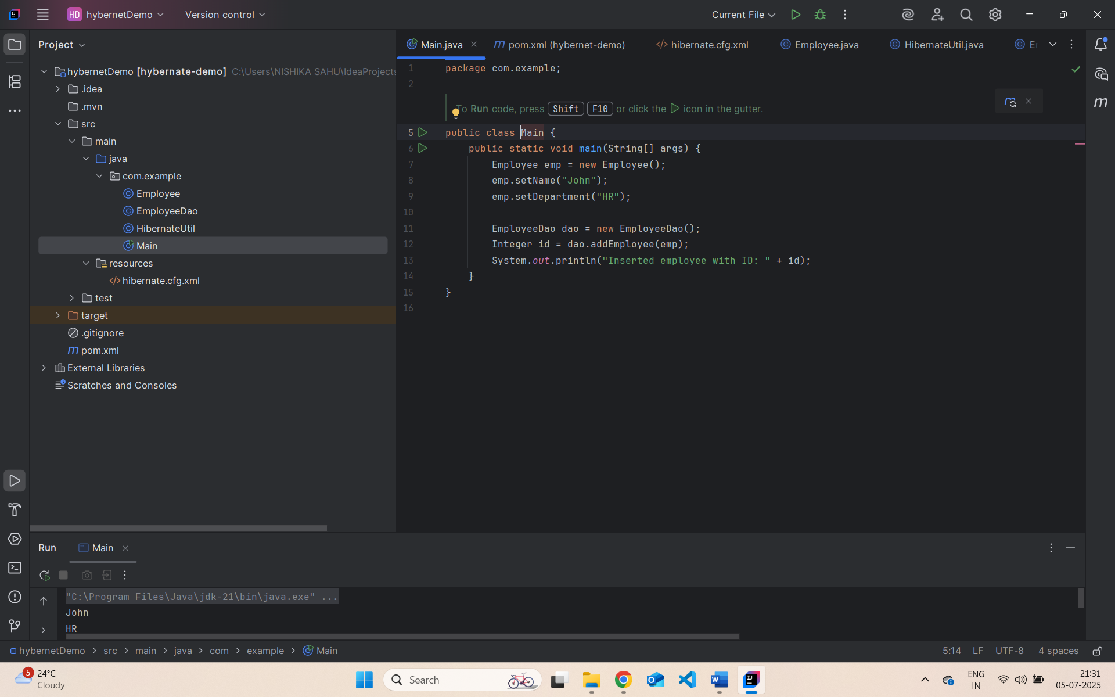

**Spring Data JPA**

